Condition | Task | Mean | Std Dev | t-stat | p-value |  | Cohen's d
Up-Regulation | HippPrac | -0.0096 | 0.2636 | -0.1546 | 0.8789 |  | -0.0364
 | Hipp1 | -0.0291 | 0.3008 | -0.4097 | 0.6871 |  | -0.0966
 | Hipp2 | -0.1161 | 0.3703 | -1.2929 | 0.2144 |  | -0.3136
 | Hipp3 | -0.0736 | 0.3724 | -0.8147 | 0.4272 |  | -0.1976
 | Hipp4 | -0.0891 | 0.4949 | -0.7201 | 0.4825 |  | -0.18
Up-Regulation vs. Rest | HippPrac | N/A | N/A | N/A | N/A |  | N/A
 | Hipp1 | -0.0103 | 0.3306 | -0.1319 | 0.8966 |  | -0.0311
 | Hipp2 | -0.0723 | 0.3429 | -0.8695 | 0.3974 |  | -0.2109
 | Hipp3 | 0.0148 | 0.2715 | 0.2255 | 0.8244 |  | 0.0547
 | Hipp4 | -0.0647 | 0.3904 | -0.6629 | 0.5175 |  | -0.1657
Up-Regulation vs. Serial Subtraction | HippPrac | 0.1694 | 0.2366 | 3.0382 | 0.0074 | ** | 0.7161
 | Hipp1 | 0.1741 | 0.2767 | 2.6698 | 0.0162 | * | 0.6293
 | Hipp2 | 0.024 | 0.2001 | 0.4938 | 0.6282 |  | 0.1198
 | Hipp3 | 0.1046 | 0.2237 | 1.9276 | 0.0719 |  | 0.4675
 | Hipp4 | 0.1365 | 0.2894 | 1.8873 | 0.0786 |  | 0.4718
Serial Subtraction | HippPrac | -0.179 | 0.2938 | -2.5851 | 0.0193 | * | -0.6093
 | Hipp1 | -0.2032 | 0.1886 | -4.5696 | 0.0003 | *** | -1.0771
 | Hipp2 | -0.1401 | 0.264 | -2.1876 | 0.0439 | * | -0.5306
 | Hipp3 | -0.1781 | 0.2955 | -2.4858 | 0.0244 | * | -0.6029
 | Hipp4 | -0.2256 | 0.3418 | -2.6404 | 0.0185 | * | -0.6601
Rest | HippPrac | N/A | N/A | N/A | N/A |  | N/A
 | Hipp1 | -0.0188 | 0.2968 | -0.2683 | 0.7917 |  | -0.0632
 | Hipp2 | -0.0438 | 0.283 | -0.6383 | 0.5323 |  | -0.1548
 | Hipp3 | -0.0884 | 0.2909 | -1.2534 | 0.2281 |  | -0.304
 | Hipp4 | -0.0244 | 0.3231 | -0.302 | 0.7668 |  | -0.0755
Supplementary Table 1. Detailed Statistical Results for the Left Hippocampus ROI Analysis.
Note: ***p < 0.001, **p < 0.01, *p < 0.05

Neuro-Regulation Metric | Correlated with | Pearson r | P-value
Average Beta | ΔSDS | 0.485 | 0.0570
 | ΔSAS | 0.282 | 0.2896
Final Performance | ΔSDS | 0.566 | 0.0221*
 | ΔSAS | 0.203 | 0.4505
Mean Feedback Activity | ΔSDS | 0.555 | 0.0257*
 | ΔSAS | 0.297 | 0.2637
Learning Potential | ΔSDS | 0.133 | 0.6239
 | ΔSAS | -0.055 | 0.8402
Non-linear Pattern | ΔSDS | 0.479 | 0.0607
 | ΔSAS | 0.115 | 0.6711
Modulation Variability | ΔSDS | 0.311 | 0.2410
 | ΔSAS | 0.262 | 0.3278
Supplementary Table 2. Full Results of Exploratory Brain-Behavior Correlation Analyses.
Note: ***p < 0.001, **p < 0.01, *p < 0.05
ΔSDS: SDS score changes between before and after training.
ΔSAS: SAS score changes between before and after training.
Average Beta：Average beta value of left hippocampus ROI across training run 1-4.
Final Performance: beta value of left hippocampus ROI during final run (Run 4).
Mean Feedback Activity: Mean beta value across runs 1,2,4 (without transfer run).
Learning Potential: the linear slope of change across 4 runs.
Non-linear Pattern: the individual quadratic trend coefficient across 4 runs.
Modulation Variability: the standard deviation of beta values across 4 runs.

Supplementary Table 3. Brain Regions Exhibiting Significant Temporal Dynamics for the [Up-Regulation > Rest] Contrast.
Anatomical Region | Hemi. | Cluster Size (kₑ) | Peak T-value | MNI Coordinates (x, y, z)
Positive Linear Trend
Anterior Cingulate / Medial Prefrontal Cortex | R | 398 | 4.20 | 6, 33, -1
Negative Linear Trend
Posterior Cingulate / Precuneus¹ | L | 222 | -4.27 | -19, -40, 12
Notes: Hemi. = Hemisphere (L = Left, R = Right). Results are from a whole-brain repeated-measures analysis testing for linear and quadratic trends (df = 45). The statistical maps were thresholded using a voxel-level threshold of p < 0.001 (uncorrected) with a cluster extent threshold of kₑ = 100 voxels.
¹The peak voxel of this cluster was located in cerebrospinal fluid (lateral ventricle), but the cluster extended into adjacent gray matter of the posterior cingulate cortex and precuneus.

Supplementary Table 4. Brain Regions Showing Significant Modulation of Activity Across Training Runs (F-contrast).
Anatomical Region | Hemi. | Cluster Size (kₑ) | Peak F-value | MNI Coordinates (x, y, z)
Temporo-occipital Cortex (MTG/IOG) | R | 685 | 21.46 | 49, -63, 7
 | L | 145 | 15.68 | -47, -70, 7
Supramarginal Gyrus | R | 407 | 13.93 | 66, -30, 27
Notes: Hemi. = Hemisphere (L = Left, R = Right). Results are from the overall F-contrast of a whole-brain repeated-measures ANOVA (df = [3.0, 45.0]). The statistical map was thresholded at a voxel-level of p < 0.001 (uncorrected) with an extent threshold of kₑ = 100 voxels.

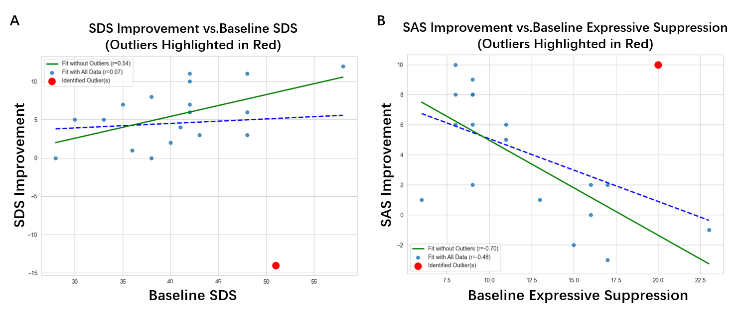
Supplementary Figure 1. Impact of Influential Outliers on Key Brain-Behavior Correlations.
Scatterplots demonstrating the effect of removing influential outliers (highlighted in red) on the correlations between baseline traits and mood improvement. The dashed blue line shows the linear fit for all data points, while the solid green line shows the robust linear fit after the outlier was excluded. (A) The correlation between baseline SDS scores and SDS improvement was non-existent with the outlier included (r = 0.07) but became significant and positive after its removal (r = 0.54). (B) The correlation between baseline Expressive Suppression and SAS improvement was moderate with the outlier included (r = -0.48) but became substantially stronger and more significant after its removal (r = -0.70). These plots illustrate the justification for the outlier exclusion procedure used for the main analyses.

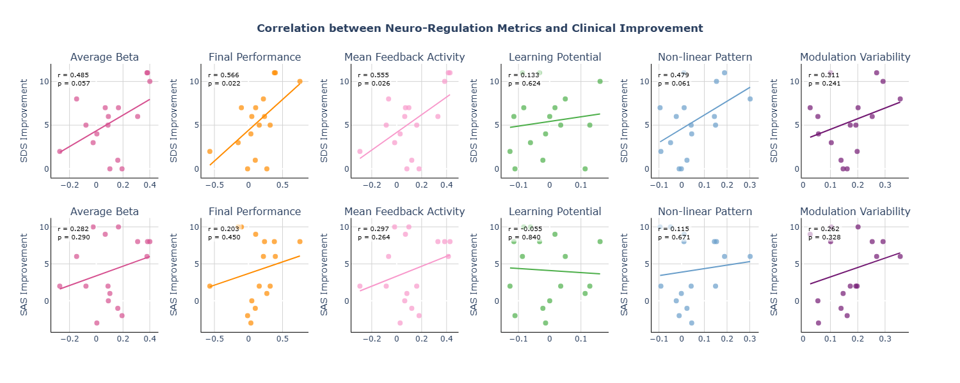
Supplementary Figure 2. Scatterplots for correlations between each of the six exploratory 'neural modulation efficiency' metrics and the improvement scores for depression (ΔSDS, top row) and anxiety (ΔSAS, bottom row).

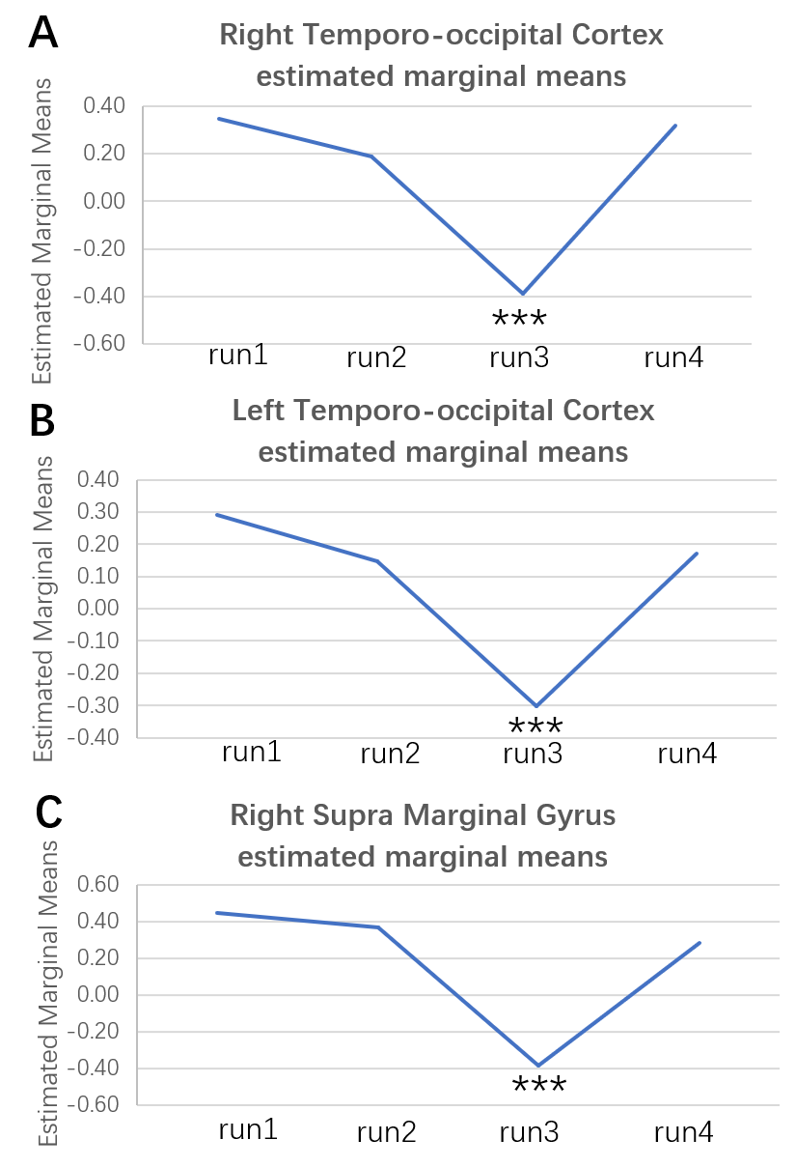
Supplementary Figure 3. Post-hoc Analysis of Regions Modulated by the Presence of Neurofeedback.
The plots display the estimated marginal means (representing BOLD activity) for each of the four training runs, extracted from the three significant clusters identified by the overall F-contrast: (A) Right Temporo-occipital Cortex (MTG/IOG), (B) Left Temporo-occipital Cortex (MTG/IOG), and (C) Right Supramarginal Gyrus. All three regions exhibit a distinct pattern: positive activation during runs with neurofeedback (Runs 1, 2, and 4) and a significant deactivation during the transfer run (Run 3) when feedback was absent. The asterisks (*** p < 0.001) indicate that the deactivation in Run 3 was highly significant.

